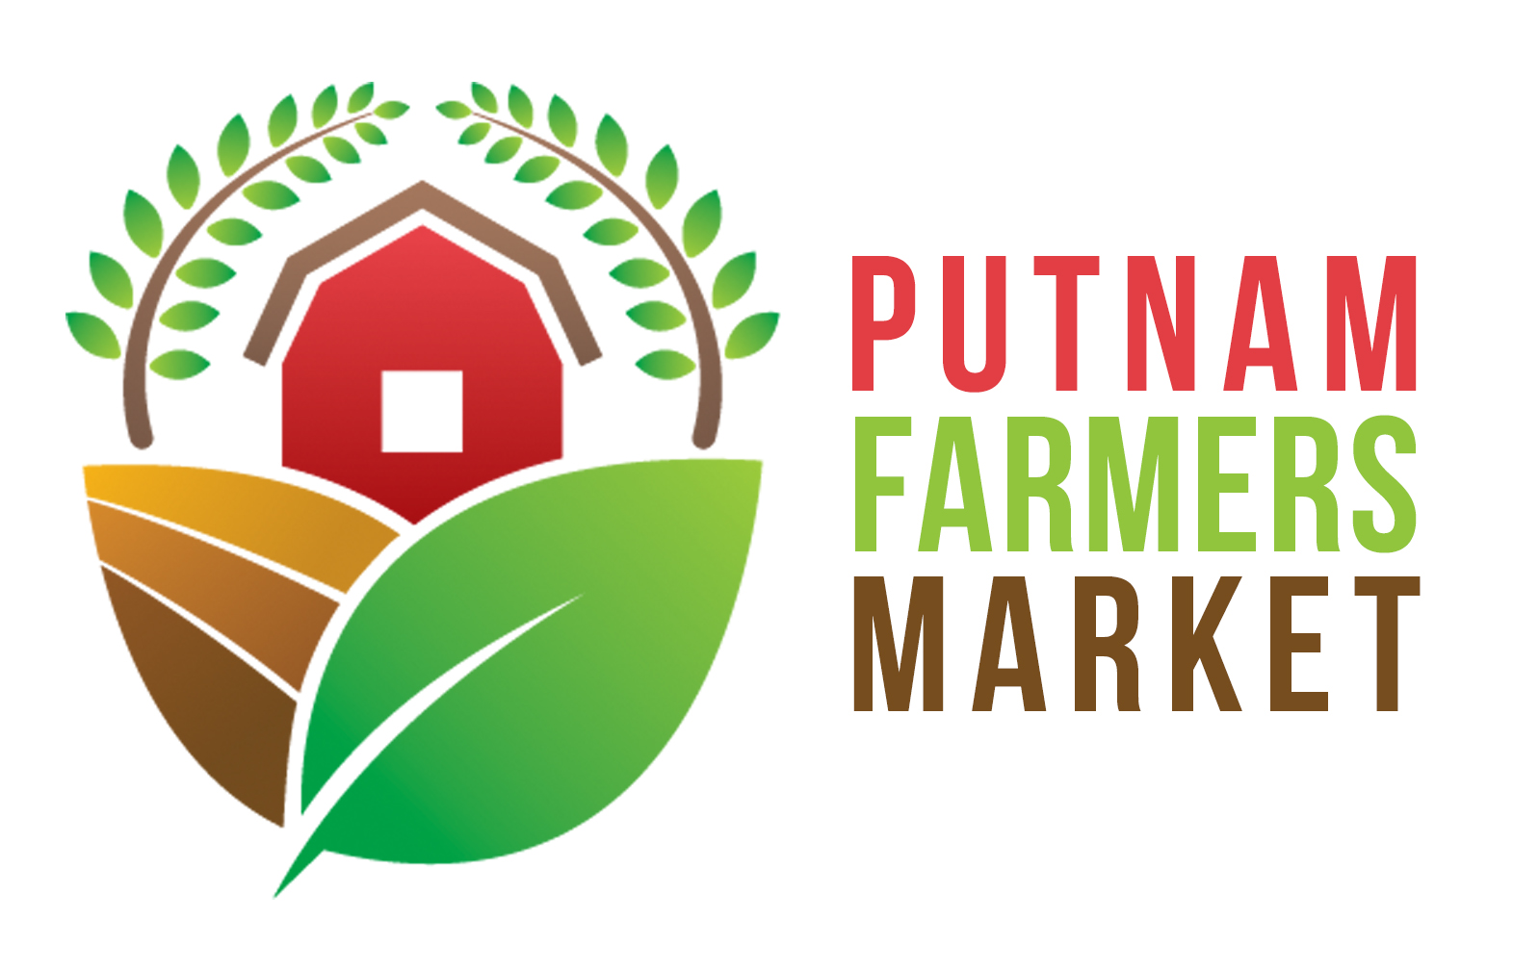

971 WV RTE 34, Suite 12
Hurricane, WV 25526
Pfmwv.com

2020 PFM Artisan & Craft Vendor Membership Application

Artisans/crafters are persons who craft with their own hands the products they offer for sale. To qualify as an artisan/crafter (hereafter, "crafter") a majority of the tools and equipment used to produce the craft must require skills and personal handling of the materials.

Crafters selling at the Putnam Farmers Market will be chosen and juried by the PFM Board of Directors with the goal of offering a variety of crafter products and a well-balanced Market to the community. The jury's decisions will be based on quality, uniqueness, and quantity.

- All craft vendor members must reside within 100 aerial miles of Valley Park, Hurricane, West Virginia, or within the state of West Virginia.
- Craft vendors may not comprise more than 40% of PFM annual members.
- All crafts must be hand crafted by the vendor or a member of the vendor's farm or business.
- Crafts must be made by hand individually - not mass produced. To be considered "hand crafted", the item must show evidence of manual skills obtainable only through a significant period of experience and dedication.
- Crafter must disclose any ready-made objects that they have enhanced or used in their craft.
  - For example: clothing, towels, linens, mass-produced vases, pottery, glass, beads, jewelry parts, art, furniture, etc. that have been embellished, decorated or painted, and/or that have been purchased and not hand produced.
- All crafts must be of excellent workmanship and design.
- No mechanical, optical, digital or electronic reproductions allowed.
  - Exceptions may be considered only if the work is derived from the crafter's original work.
- Photography will be permitted with the following conditions:
  - It must be original photography of the vendor.
  - "Limited edition reproduction" must be clearly displayed on the reproduced items.
  - Greeting cards, postcards, and prints are allowed only with prior jury approval and must be noted on the application.
- ALL crafts will be juried. Craft vendors who add a new category of crafts after jury selection will still have to have the new item juried. Jury requires examples of each craft category that the crafter wants to sell. High quality, recent photographs of the crafts and a craft description must be submitted with the crafter's Vendor Application. The jury reserves the right to ask for additional information and/or for the item to be brought in to be judged.
- The Putnam Farmer's Market Board of Directors will meet as necessary prior to the start of the market season to jury new crafts and craft vendors. Periodic jury selection for applications submitted during the season will be conducted on an as-needed basis.

2020 PFM ARTISAN & CRAFT VENDOR APPLICATION
Page 2

Your Artistic Medium:
Ceramics Drawing & Pastels Fiber Glass Jewelry Leather
Oil/Acrylics Painting Photography Printmaking/Graphics Sculpture
Wearable Art Wood Quilting Other:

Price Range: $ to $
Crafter/Business Name:
Contact Person Name: Spouse/Partner Name:
Mailing Address:
City: State: Zip:
Email:
Website:
Social Media Address/es:
Home Phone: Cell Phone:

Please describe and attach photographs (or links to photographs) of your art/craft including ALL work you wish to exhibit. Please carefully consider the information that you write and be sure to include all relevant details. Describe your craft, the process and materials used to create you work. During the jury process, in addition to your work or photos, what you write below will become all the information that the craft jurors will shave about your product. Your descriptions are an important aid in helping to evaluate your work.

Describe your craft:
Describe the materials used to create your craft:
Describe the process that you use to create your craft:

2020 PFM ARTISAN & CRAFT VENDOR APPLICATION
Page 3

☐I DO ☐I DO NOT…give PFM permission to use my information for PFM promotional purposes.

Agreement to Market Rules and Bylaws: By signing below, I acknowledge that I have read all rules and bylaws of the Putnam Farmers Market and understand them fully. I agree that I (and my business partners, employees, and associates) will abide by the Putnam Farmers Market rules and bylaws. I agree to the penalties, fines, and grievance policies outlined in the PFM market rules and bylaws.

Indemnification and Release of Liability: By signing below, I agree that I, (and my business partners, employees, and associates) (hereafter, “Vendor”) agree to release and hold harmless from all liability the Putnam Farmers Market Association & the Putnam County Parks and Recreation Commission, and their agents, employees, board members, or officers (hereafter “PFM & PCPRC”) from any personal injury claims or property loss claims that may arise as a result of my membership and participation in the Putnam Farmers Market. Vendor waives, releases, and discharges any and all claims against PFM &PCPRC for damages, personal injury, death, financial loss, or property damages that may occur or accrue as a result of activity at the Putnam Farmers Market. Vendor accepts all responsibility and liability for adherence to any external regulations applicable to the Vendor product, and the Vendor releases and holds harmless from all such liability the PFM & PCPRC for any claims that may arise due to the Vendor failing to comply with such external regulations.

Vendor Signature: _______________________________________________ Date: __________

Printed Name: _________________________________________________________________
Please remit your member application fee of $50 to the Putnam Farmers Market, 971 WV RTE 34, Suite 12, Hurricane, WV 25526.
Putnam Farmers Market does not discriminate on the basis of race, color, religion, sex, national origin, age, marital or veteran status, political affiliation, handicapped status, or any other legally protected status.

