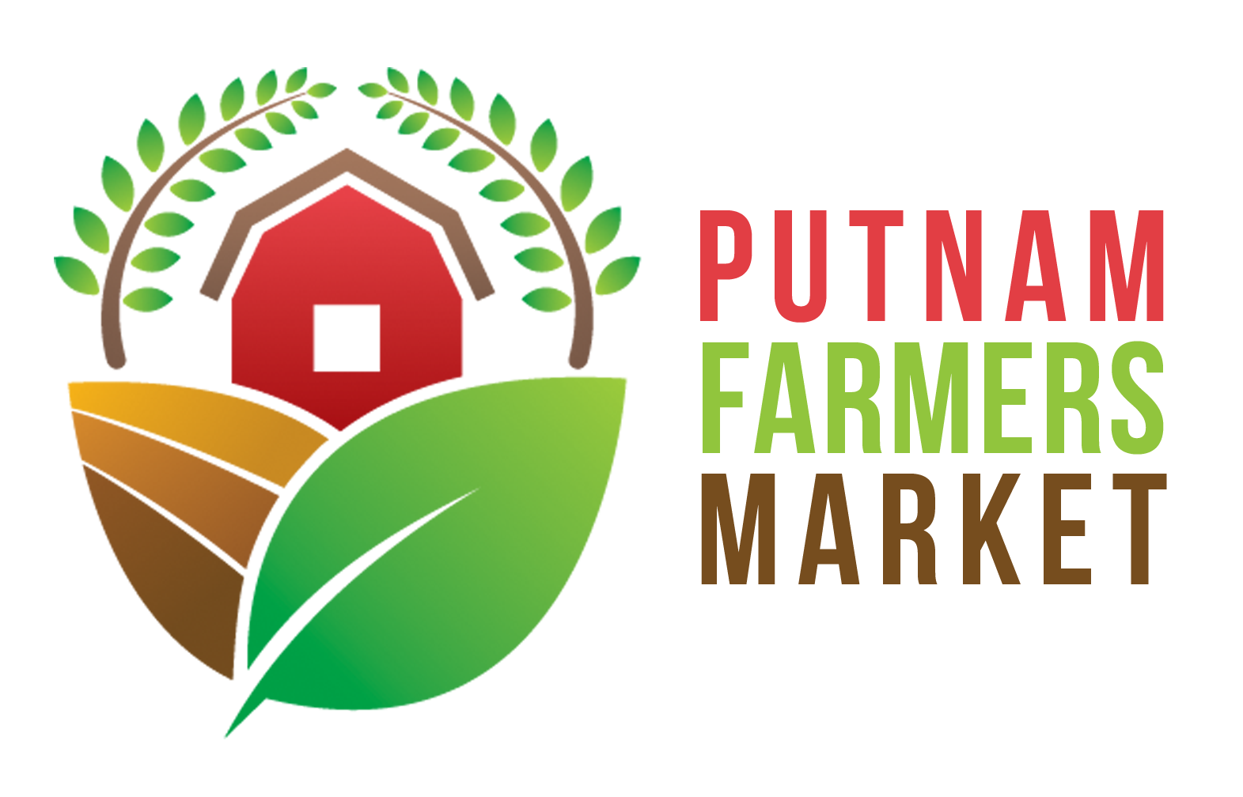

Putnam Farmers Market Rules

- Dates and Time of Market: The Putnam Farmers Market will open for seasonal operation, with dates and time to be approved each year by the PFM Board of Directors.

Preferred Dates of Operation:
Every Saturday from May through October
Opening Date: First Saturday in May
Closing Date: Last Saturday in October

Preferred Times of Operation:
9:00 AM to 1:00 PM

- Location of Market Sales: The Market will operate at Valley Park in Hurricane, WV.

- Vendor Set Up, Attendance, and Punctuality: Vendors should notify the Market Manager 1) when they are planning to attend the Market for the first time each season 2) if they will be absent on a Market day 3) when they plan to attend for the last time each season. Vendors must arrive in time to be ready to sell at the official opening time. After the opening bell rings, vendors must be at their tables prepared to sell, so as to prevent disruptive and unsafe behavior such as carrying of products across the Market or moving vehicles during times customers are present. Vendors must check in with the Market Manager upon arrival and will be directed to an assigned or open available space. Market Manager approved vendors may set up an hour before opening time and set up shall be completed 15 minutes before opening time.
Penalty for late set up: (For vendors not set up by 9:00am) First offense is a written warning; second offense is a $10 fine; third offense is $20 fine; additional offenses shall be subject to Board of Director review and additional penalty.

- Market Day Sell Times: No sales are allowed before the opening time or after the closing time. Orders may be taken prior to Market day, but shall not be filled until after the opening bell. For example: if a customer orders a bushel of tomatoes prior to Market day, the vendor may set back or reserve the tomatoes, but the vendor may not take money or hand over the tomatoes to the customer until after the opening bell.
Penalty for early sells: First offense is a written warning; second offense is out 1 selling day; third offense is out an additional selling day and a $25 fine.

- Market Manager: The Market Manager is appointed by the Board of Directors each season and follows the list of duties approved annually by the Board of Directors.

- Producer-Only Rules and Exceptions: The goal of the Putnam Farmers Market is to support local agriculture in Putnam County and surrounding counties. As such, all products displayed must be produced “locally”by the producer-vendor who sells them (see exception below). A producer-vendor may be a sole proprietorship, partnership, or corporation.

“Local” Exception: The re-sale of agricultural products by producer-vendors is not permitted, unless the product is otherwise unavailable at the Market. In that case, the producer-vendor can purchase that product from another “local” or WV producer as a supplement under a provisional arrangement. The Market Manager will approve each provisional arrangement and proof of purchase of the product must be shown. Should another producer-vendor begin offering that product produced on her/his farm, the vendor selling the supplemental product under provisional arrangement must stop selling that purchased product. Exceptions can be made to the local producer rule on a case by case basis for products that are not available within the local area. These cases must be brought to the Market Manager and/or Board of Directors for approval on a weekly basis.

“Local”/ “Locally” in this case means Farmers within a one hundred (100) air mile radius of Valley Park, Hurricane, WV, or a resident farmer of West Virginia with preference given to producer-vendors closest to Valley Park.

“Vendor” may be the actual producing individual, an immediate family member, another producer member, staff or employee of the producing individual’s farm.

- Allowable Products: Producer-vendors shall submit a product plan with their application at the beginning of each season indication the crops and products they plan to sell at the Market. Products should fall into one or more of the following categories:

  - Vegetables/Fruits/Herbs grown by the farmer/grower, including mushrooms.
  - Eggs, which are from the producer-vendor’s, own poultry and kept at 41 degrees F.
  - Cheeses or other value-added products from milk produced on the producer- vendor’s farm or purchased from “local” dairy farms. All dairy products must be pasteurized and in accordance with state and county health codes.
  - Meat from livestock raised by the producer-vendor and which has been processed at a USDA OR WVDA inspected facility. Meat vendors must have a Meat Distributors License. The Code of West Virginia Regulations, Title 61, Series 16 recognizes a federal exemption that allows individuals that raise poultry in West Virginia to slaughter and sell up to 1,000 birds per calendar year without inspection. Rabbit meat vendors registered with the WVDA and in compliance with WV Code may sell at the Market.
  - Fresh baked goods from scratch (not store bought mixes), using at least one “local” seasonal ingredient in the products for sale. Eggs, fruit, herbs or vegetables used as ingredients in the baked goods must be grown by the producer or purchased from a “local” grower. (Example – if blueberry muffins are sold the blueberries and/or eggs must be “local” for the muffins to be an allowable item.) Vendors selling only baked goods are considered under the “craft” category and must be judged and accepted by the Board. Vendors already selling produce or meat are exempt from the craft rule as long as no more than 50% of their inventory is baked goods.
  - Jams, honey, maple syrup, and other value-added products which are freshly made from scratch by the vendor (not using store-bought mixes), using seasonal ingredients from their farm or another “local” farm. Processing must comply with local and state health codes. (See note at the end of rule number
  - Sauces, salsas, canned vegetables and fruits must be processed by a licensed processing facility. Cider or other juices must be produced from the producer-vendor’s own fruits or that of other “local” producers, but may be processed off-farm. Vendors should be prepared to provide the Market Manager with the name and contact information of the processing facility when asked.
  - Potted plants, shrubs, or annual bedding plants which are raised from seed or cuttings. Greenhouse operations may be reviewed and approved by the Board on an individual basis.
  - Cut flowers which were grown on the grower’s own farm or greenhouse.
  - Straw, hay, compost, or other agricultural products which are produced by the producer-vendor.
  - Soaps/Candles/Body Care products which are handcrafted using seasonal ingredients from their farm or another “local” farm. Any herbs, milk, honey, or other natural products included in the products should be grown by the producer-vendor or purchased directly from another “local” producer. Candles and soaps should be naturally-based from a product grown in the ”local” area (milk, honey, etc., NOT soy or other product of unknown origin).
  - Crafts/art handcrafted by any food or craft/artisan vendor must be judged on a category basis by the Board before being admitted to the Market. A maximum of 40% registered artisan/crafter annual memberships may be granted each season.
  - Wools and pelts/fleeces which are from the farmer’s own animals. No more than 25% of non “local” fibers may be added to the yarn during spinning. Carding, cleaning, processing and spinning of pelts may be done off-farm, but the vendor should be prepared to provide the Market Manager with the name and contact information of the facility when asked.
  - Prepared/Cooked On-Site Food may be served at the market, but must include some “locally” raised ingredients. Such vendors must show proof of required operating permits, such as local health department permits.
  - Other farm-related products not listed here, which may be sold through a provisional arrangement. Permission to sell a product not included in items a-n should be requested from the Market Manager prior to sale at the Market. The Market Manager may refer such requests to the Board of Directors.

- Vendor Membership: All persons intending to sell at the Putnam Farmers Market must, prior to participation in the Market, file a vendor application each year with the Market Manager and/or Board of Directors. This document requires the producer-vendor to:
  - Become a member of the Market by paying the vendor membership fee.
  - Verify that she/he/they are the actual grower or producer of the specified items that they intend to sell. All new applicants may be visited by the Verification committee.
  - List farm name and contact information for farm, home and office.
  - Agree to Market Rules, By-laws, and related regulations.

Additional vendors will be added to the Market at the beginning of each season, or as need permits and space allows. For a new season, previous full-time vendor members in good standing will receive first priority, followed by late joiners in good standing, then by applicants in the chronological order of their application. The Market Manager and/or Board of Directors reserve the right to refuse Market participation to any new applicant if the producer-vendor is proposing to sell products already in abundant supply at the Market. The producer-vendor applicant will be put on a waiting list for possible openings in the future.
Member in Good Standing Definition: Member in good standing is the status assigned to a member of an organization when he or she has remained current on the organizational dues and payments. The term, however, must be construed under ordinary rules and with reference to the by-laws and Market rules of Putnam Farmers Market.
- Annual Vendor Membership Fees: Annual membership fee of the PFMA is $50 and should be submitted to the Market Manager or Board of Directors no later than the vendor’s first attended Market day. Membership fees are non-refundable.
Late Payment Penalty: Any vendor who fails to pay their membership fees in full by their first attended Market day will be charged an additional $20 late payment fee. Payment of the late fee will be required before further participation in the Market will be permitted.

- Annual Member Spaces & Fees: Annual members will be assigned a permanent Market space for the entire current Market season in exchange for their Vendor Membership Fee. Additionally, each member shall pay a $10 daily Market space fee at each Market the member attends. The $10 daily fee includes $5 being dedicated to the Market Manager’s compensation. Market days of low customer turnout (less than forty) $5 will be collected for the Market Manager compensation only. The Board of Directors may choose to determine premium spots and set related additional space fees annually. The Market Manager may, at his or her discretion, allow or require vendors to move from their permanent space for a single Market day to improve the flow of the Market traffic.

- Member Space Assignment: The Board of Directors may assign permanent full-season spaces by random draw and/or by collecting premium fees. The Board of Directors may chose to give space assignment priority to members in good standing from the previous Market season. Space assignment may be prioritized to improve the flow of Market traffic.

- Purchasing Multiple Spaces: Annual Members may purchase more than one space if space is available for an additional fee of $50 per season per space, and an additional $10 per market day attended.

- Guest Vendors & Guest Vendor Space:

    - Guest Vendors shall fill out a Guest Vendor application, and may be permitted at the Market after Board of Director review & approval.
    - Guest Vendors must comply with all Market Rules and By-Laws, except Annual Vendor Membership Fees and Annual Space rules.
    - Approved Guest Vendors should coordinate dates of attendance with the Market Manager or President of the Board of Directors the week of planned attendance. Approved Guest Vendors shall be permitted at the Market as space allows. Guest Vendor space will be assigned on a first come, first serve basis.
    - Guest Vendors must pay $10 for each Market day attended.
    - Guest Vendors may participate annually in the Market up to, but not more than, four Market days in a single Market season, after which the vendor must apply to be an Annual Member to continue to participate in the Market.
    - If an approved Guest Vendor applies to become an Annual Member, any Guest Vendor Fees paid during that same Market Season may be credited toward their Annual Vendor Membership Fee.

- Educational and Community Activities: Space will be made available free of charge for educational activities relating to sustainable agriculture and for non-profit community groups. This space will be made available on a first-come, first-serve basis, but must be approved and booked by the Market Manager and/or Board of Directors in advance.

- Market Manager Space: One space will be held by the Putnam Farmers Market as the Market Manager’s space.

- External Regulations: Vendors are responsible for compliance with applicable park, city, county, state and federal regulations and for supplying the Market Manager with proof of such. Regulations such as (but not limited to):
- Agricultural business license.
- Pesticide licensing and safe use.
- Approval seal on weighing devices granted by the WV Division of Labor
- State sales tax collected as required.
- Organic certification on claimed products as required.
- Food safety, sanitation, health permits and labeling issues that apply to the item.
- State inspection of nursery stock required for selling whole plants for replanting (packs or pots).

- Market Signage:
- Producer-vendors will display a sign identifying the name and location of their farm or business.
- Producer-vendors must have signs, Boards, tags, or labels listing prices of every item for sale.
- Producer-vendors listing “organic” produce, or calling their produce “organic,” must display a sign giving their organic grower’s certification and their certifier’s organization, unless exempt from certification. Proof of exemption from organic certification should be available for the Market Manager’s inspection if so requested.
- Producer-venders should clearly separate and label organic and non-organic produce in the same display.
- Signs must be posted before sales begin.
- Producer-vendors must display any other signs required by local, state, county, state, or federal regulation.
- Participating producer-vendors must display any signage required by programs such as SNAP, senior-voucher programs, or other food assistance programs.

- Marketing Committee: The President of the PFM Board of Directors may annually appoint a Marketing Committee of up to 3 members to review and approve all Market signage and Marketing materials. The Marketing Committee may review any vendor signage or marketing materials displayed at the Market, and require signage removal if it is deemed inappropriate by the Committee.

- Clean up: Producer-vendors must clean up the area around their vehicles and sales area before leaving Producer-vendors must remove containers, waste and trimmings before leaving the Market site and take any trash or garbage they have generated at the Market back to the farm. The Market Manager will be responsible for ensuring that any trash from public traffic at the Market sites is properly removed and disposed of at the close of each Market day.

- Public safety: Shade structures must be secured to prevent wind damage or injury. No dogs or other animals allowed with the exception of service animals for disabled. Only new or reusable bags can be used. Absolutely no recycled bags.

- Market behavior: Vendors are independent entrepreneurs with a common stake in creating a vibrant Marketplace. Activities that seem to violate normal sales practices and these Market rules can be questioned by other vendors. The Market Manager will assist in finding a resolution. If this fails, the Board of Directors will conduct a vote if requested. When a vote on an alleged “abnormal activity” favors a change in a vendor’s practice, the vendor in question must comply. See Market Rule Enforcement and Grievance Policy for the process to be followed.

“Abnormal Activities” include but are not limited to:
- Unsafe conditions or hazards at sales area.
- A stand that impedes access to other vendors.
- Condition of sales area, products, or vendor behavior that detracts from the Market’s appearance, overall quality or reputation.
- Harassment, either verbal or physical.

- Gross vendor sales must be reported on a weekly basis per Market. Failure to remit weekly Market sales may result in fines to the vendor and a vendor may be suspended from the Putnam Farmers Market. Fines will be as follows: first offense $10; second offense $25; and third offense suspension from the Market for the rest of the season.

- Vendor Member Sabbatical: Any full-time member in good standing (all past fees paid) and a member for at least three years may request that the Board grant a sabbatical leave for as long as one full season.

- Market Rules Enforcement and Grievance Policy

The Market Manager ensures compliance with the Market rules; however, the Market Manager has the authority to grant exceptions to the Market rules on an individual basis for reasons of dire need. The Market Manager has the authority to impose disciplinary action at the Market site when needed. In the event of customer dissatisfaction with a particular vendor or some aspect of Market operations, the dispute must be resolved to the satisfaction of the customer, vendor, and Market Manager in a timely manner. All violations of the Market Rules as well as customer or fellow vendor complaints should be reported by the Market Manager to the Board of Directors (BOD) at the next BOD meeting.

Some violation penalties and procedures are prescribed previously in these Market Rules, and should be followed accordingly. The procedure regarding all other violations of the Market rules, Market By-Laws, or a complaint of “abnormal Market behavior” is as follows:

First Offense: Verbal warning from the Market Manager and/or the President of the Board of Directors.
Second Offense: Vendor will receive written notification of violation from the Market Manager and/or Board of Directors.
Third Violation: The Market Manager will present the violation at the next Board of Directors meeting, and the Board of Directors will determine further remedy which may include temporary removal from the Market, seasonal removal from the Market, and/or fees to cover damages incurred due to the violation, and/or other remedies that the Board of Directors determines appropriate. The Board’s ruling shall be provided to the vendor in writing after Board review and vote.

Removal From Market:

- Immediate Removal: Failure by a vendor to comply with the Market Rules or comply with the Market Manager’s resolution of complaint of “abnormal Market behavior” can result in the temporary removal of the vendor from Market participation by the Market Manager immediately for that full selling day if the Market Manager determines safety and/or security is an issue.
- Any vendor removed due to safety and/or security issues shall be reviewed during the next Board of Directors meeting, and shall not return to the Market until/unless given approval do to so by the Board of Directors.
- The Board of Directors may choose to revoke vendor membership temporarily or permanently upon any first offense violation deemed to be a safety or security issue.
- Upon being asked verbally or in writing to remove from the Market, the vendor shall promptly vacate premises, and remain off premise for the duration of time ordered by the Market Manager and/or Board of Directors.
- Upon failure to vacate, the Market Manager and/or Board of Directors may remove the vendor’s property from the premises at the vendor’s expense. The PFM shall not be responsible for storage or safekeeping of property so removed. The Market is relieved and discharged from any and all losses or damages caused by removal of vendor property from the Market.
- The PFM, its volunteers, and its staff shall not be held liable for any loss of sales or direct or indirect damages incurred due to temporary, seasonal, or permanent removal from the Market.

Vendor Grievance Policy:

Any vendor has the right to a hearing before the Board of Directors. A request for such a hearing should be submitted in writing and signed by the complainant to the Market Manager and/or President of the BOD. The BOD has one (1) week to respond to the vendor’s request for a hearing. A hearing should occur no later than two (2) weeks from submission of the written request for a hearing. The hearing shall be conducted by the BOD and open to any PFM members who want to observe. A majority vote by the BOD shall determine the final resolution of the grievance by the vendor.

- Indemnification and Release of Liability

Vendor must agree to release and hold harmless from all liability the Putnam Farmers Market Association & the Putnam County Parks and Recreation Commission, and their agents, employees, board members, or officers from any personal injury claims or property loss claims that may arise as a result of the Vendor membership and participation in the Putnam Farmers Market. Vendor must waive, release, and discharge any and all claims for damages, personal injury, death, or property damages that may occur or accrue as a result of activity at the Putnam Farmers Market. Vendor must accept all responsibility and liability for adherence to any external regulations applicable to the Vendor product, and the Vendor must release and hold harmless from all such liability the Putnam Farmers Market and the Putnam County Parks and Recreation Commission, and their agents, employees, board members, or officers for any such claims that may arise due to the Vendor failing to comply with external regulations.

This version approved 11/10/19 at the PFM Annual Membership Meeting.

