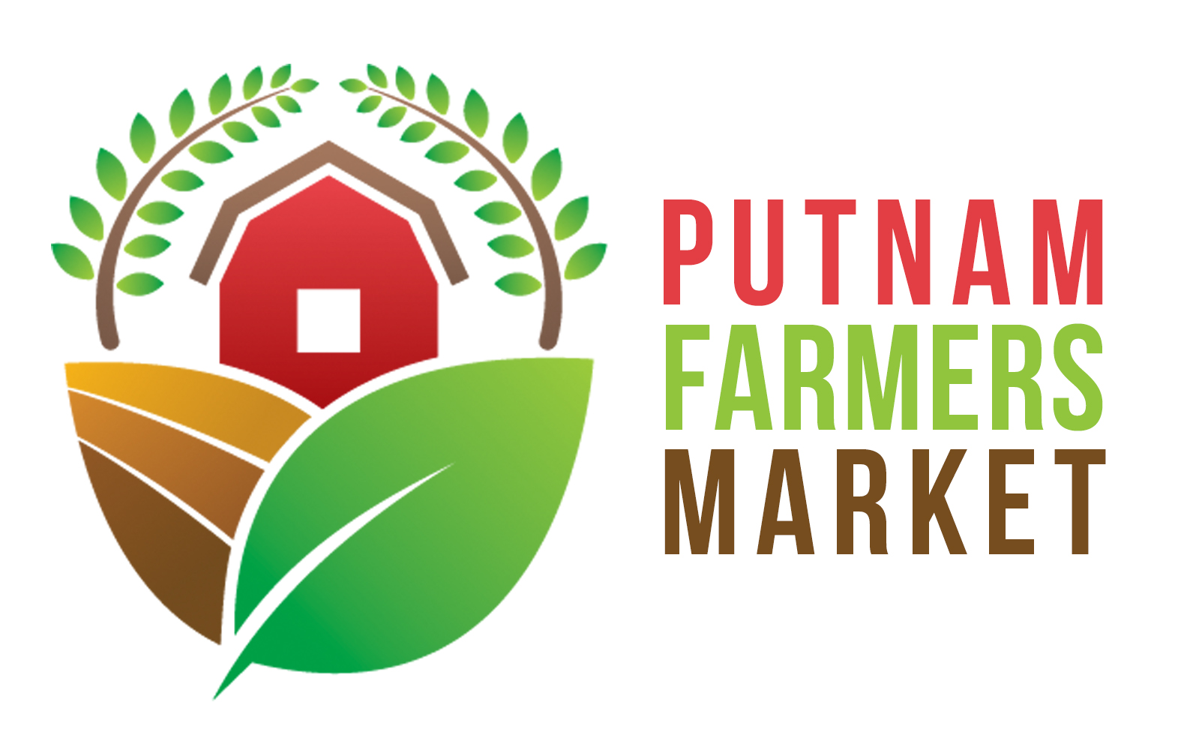

971 WV RTE 34, Suite 12
Hurricane, WV 25526
Pfmwv.com

Farm/Business Name:
Contact Person Name: Spouse/Partner Name:
Mailing Address:
City: State: Zip:
Email:
Website:
Social Media Address/es:
Home Phone: Cell Phone:
2020 PFM Produce Vendor Annual Membership Application

1) What items do you intend to sell at the Putnam Farmers Market?

Vegetables  artichoke | pumpkins | Fruit  apples | Other Items  baked goods
asparagus | radishes | apricots | crafts*
beans, lima | rutabaga | blackberries | eggs
beans, snap | salsify | blueberries | gourds
beets | spinach | cherries, sweet | herbs: list under “other”
broccoli | squash, summer | cherries, tart | honey
brussel sprouts | squash, winter | currants | jams, jellies
cabbage | sweet corn | elderberries | maple syrup
carrots | sweet potatoes | fig | trees/plants/flowers: list
cauliflower | Swiss chard | gooseberries | under “other”
celeriac | tomatoes | grapes | Other:
celery | turnips | kiwifruit
Chinese cabbage |  | lingonberries
collards |  | muskmelon
cucumbers | Other: | nectarines
eggplant  endive  garlic  kale  kohlrabi  leeks  lettuce, leaf  mustard  okra  onions, green  parsley  parsnips  peas |  | peaches  plums  raspberries  strawberries  watermelon  Other: | Meat:  pork  beef  chicken  rabbit  lamb  chevon  Other:  _____________________
peppers | * Crafts must be judged on a category basis by the Board before being admitted to the Market.

2020 PFM PRODUCE VENDOR APPLICATION
Page 2
2) Are these items grown and/or handmade by yourself, your employees, or someone in your
family? If no, please explain: ____________________________________________________________________________________________________________________________________________________________

3) Please provide directions to the location where your crops are grown and/or food is made:
__________________________________________________________________________________________________________________________________________________________________________________________________________________________________________

4) Fruit and vegetable producers: Are you any of the following?
___Certified Organic Practice ___Traditional ___ Transitional ___ Organic
Other certification or noteworthy growing practices? Please explain:
____________________________________________________________________________________________________________________________________________________________

5) Please provide a short promotional description of your farm:
______________________________________________________________________________________________________________________________________________________________________________________________________________________________________________________________________________________________________________________________________________________________________________________________________

☐I DO ☐I DO NOT… give PFM permission to use my information for PFM promotional purposes.

Agreement to Market Rules and Bylaws: By signing below, I acknowledge that I have read all rules and bylaws of the Putnam Farmers Market and understand them fully. I agree that I (and my business partners, employees, and associates) will abide by the Putnam Farmers Market rules and bylaws. I agree to the penalties, fines, and grievance policies outlined in the PFM market rules and bylaws.

Indemnification and Release of Liability: By signing below, I agree that I, (and my business partners, employees, and associates) (hereafter, “Vendor”) agree to release and hold harmless from all liability the Putnam Farmers Market Association & the Putnam County Parks and Recreation Commission, and their agents, employees, board members, or officers (hereafter “PFM & PCPRC”) from any personal injury claims or property loss claims that may arise as a result of my membership and participation in the Putnam Farmers Market. Vendor waives, releases, and discharges any and all claims against PFM &PCPRC for damages, personal injury, death, financial loss, or property damages that may occur or accrue as a result of activity at the Putnam Farmers Market. Vendor accepts all responsibility and liability for adherence to any external regulations applicable to the Vendor product, and the Vendor releases and holds harmless from all such liability the PFM & PCPRC for any claims that may arise due to the Vendor failing to comply with such external regulations.

Vendor Signature: _______________________________________________ Date: __________

Printed Name: _________________________________________________________________
Please remit your member application fee of $50 to the Putnam Farmers Market, 971 WV RTE 34, Suite 12, Hurricane, WV 25526.
Putnam Farmers Market does not discriminate on the basis of race, color, religion, sex, national origin, age, marital or veteran status, political affiliation, handicapped status, or any other legally protected status.

